QC_Guru99

Introduction

Mercury Interactive’s Quality Center is a test management tool.

It is a topped-up version of Mercury Test Director.

Quality Center offers an organized framework for testing applications.

It is a web based tool which manages all aspects of testing process which otherwise is a time consuming task.

It can be attached to our Email system so that the information about defect tracking can be supplied to all concerned persons e.g. developers, persons in customer support and quality assurance personnel.

This tool can be integrated with automation testing tools e.g. WinRunner, LoadRunner etc. as well as requirement and configuration management tools so that we can get a fully automated application testing.

Enter Quality Center URL on the browser : <http://150.235.35.24/qcbin/stsart_a.htm>

**Introduction to main components of Quality Center**

* Quality Center categorizes your Test artifacts using Domain and Projects
* A Domain is an independent [business software[](http://www.guru99.com/quality-center-tutorial-2.html)](http://www.guru99.com/quality-center-tutorial-2.html) department like ERP , CRM , Banking etc.
* Project is an independent [software[](http://www.guru99.com/quality-center-tutorial-2.html)](http://www.guru99.com/quality-center-tutorial-2.html) team under a given department. Example, for Banking domain there could be teams for net banking treasury [wealth management[](http://www.guru99.com/quality-center-tutorial-2.html)](http://www.guru99.com/quality-center-tutorial-2.html) etc
* The basic modules in Quality Center are Requirements , Test Plan, Test Lab & Defects which are used most frequently.
* Additional modules in Quality Center are Business Components, Dashboard as well as  Resources and Dependencies (in QC version 10.0)

## What is Requirements Module in Quality Center?

* The requirements module in Quality Center is used to store your Test Requirements. On the basis these stored requirements you will build your test cases.
* A parent requirement could have a child requirement.
* Each requirement is assigned a unique id for identification.
* View requirement such as Tree, Grid and numeration.
* Modify requirement i.e., copy and paste, or cut and paste or delete.

In Requirement Module,

Set up : Name, Author, Priority, Product , Reviewed, Type and Description.

Set up Parent , Child requirement and/or another child requirement.

Requirements Module

Requirement module is used to store all requirements related to a testing project.

Requirement are specified in Quality Center by creating a requirements tree.

Requirements Tree is a graphical representation of requirements specifications.

Requirements can be grouped, sorted and monitored in the requirements pane.

Requirements can also be linked to Tests created in Test Plan Module, Defects in Defect Module.

If a test requirement changes, you can immediately identify the affected test cases and defects.

Afer the requirements are bases lined and Test Strategy is determined, Tet planning phase begins.

Test plan module is used to keep all data related to Test planning e.g. Test Plan and Test Cases in Quality Center.

A Test Plan Tree is graphical representation of Test Plan, displaying your tests according to a hierarchical relationship of their functions.

This phase starts with developing a Test Plan tree in the Test Plan Module where Scope items/Work Request/ Testing units are mapped as Subjects.

Subjects ---🡪 Tests --🡪 Test Steps

Requirements and Test Steps can be linked.

Once test planning is complete, tests can be automated using HP Testing Tools.

## Test Plan Module in Quality Center

* You will use the Test Plan module in Quality Center to design and create your test cases/scripts.
* You can link your Tests in Test Plan Module with Requirements in the Requirement Module for easy tracking.
* Quality Center provides many a features like copying test steps , emailing scripts for review , adding attachments etc.  to facilitate faster development of test cases.

## Automated Test Case Design

* Quality Center provides many a features like copying test steps , emailing scripts for review , adding attachments etc.  to facilitate faster development of test cases.
* You can create a script in Automation tools like QTP and Loadrunner , and then upload and store them in Quality Center
* You can also directly convert a Manual Test Script in Quality Center into an Automated Script.

## modify and link tests

## You can set the sequence of your test cases in Quality Center

* You can make  call to a test just like call by reference in [programming[](http://www.guru99.com/quality-center-tutorial-6.html)](http://www.guru99.com/quality-center-tutorial-6.html) languages
* You can link a Test and Requirement in Quality Center. This linking can be done in two ways

1. Linking a Test to a Requirement
2. Linking a Requirement to a Test

Send by email test.

Test steps can be edit, copy, delete, parameterize and so on.

Test Lab Module

* You will use the **Test** Lab module in Quality Center to execute your test cases
* Before you begin execution , you need to create a "Test Set Tree"
* To create a Test Set Tree , you need to first create  a "Test Set Folder"
* Next, you will add "Tests" created in the Test Plan Module, to your Test Set Folder.
* A Test Set Folder together with added Tests is called the Test Set Tree (since it looks like a tree structure.)
* Test sets can include both manual and automated Test .
* You can include the same Test  in different Test Sets or add multiple instances of a Test to the same Test Set.

Quality Center also provides for scheduling where in you can specify the date and time of execution of your Test Sets.(Dependency)

Quality Center also provides Conditional testing i.e., Yahoo_Search will execute after executing Yahoo_Login.

run a test (in Test Lab module) in Quality Center

* You can schedule your automated test in Quality Center to run at a designated date and time on  a specified machine .
* Run test(s) in local machine or remote machine in Quality Center.
* The test are run in QTP by opening the browser and results are stored in Quality Center.

You can run few or all the tests in a Test Set.

Defects Module in Quality Center

* You will use the **Defects** Module in Quality Center to raise and track  bugs.
* Defects tracking is done in Defects Module.
* It is used to keep all data related to Defects.
* A Defect can be added during any stage of your test execution.
* It is possible to add a Defect in Test Lab module while running a test case.
* It can be done by clicking on the New Defect button in Defect.
* For ease of use, Quality center also provides for adding defects by importing them from an excel.

You can also email a defect or add a defect as a Favorite

Create a Defect.

Modify/Email /Link a Defect.

Add Defect to Favorite.

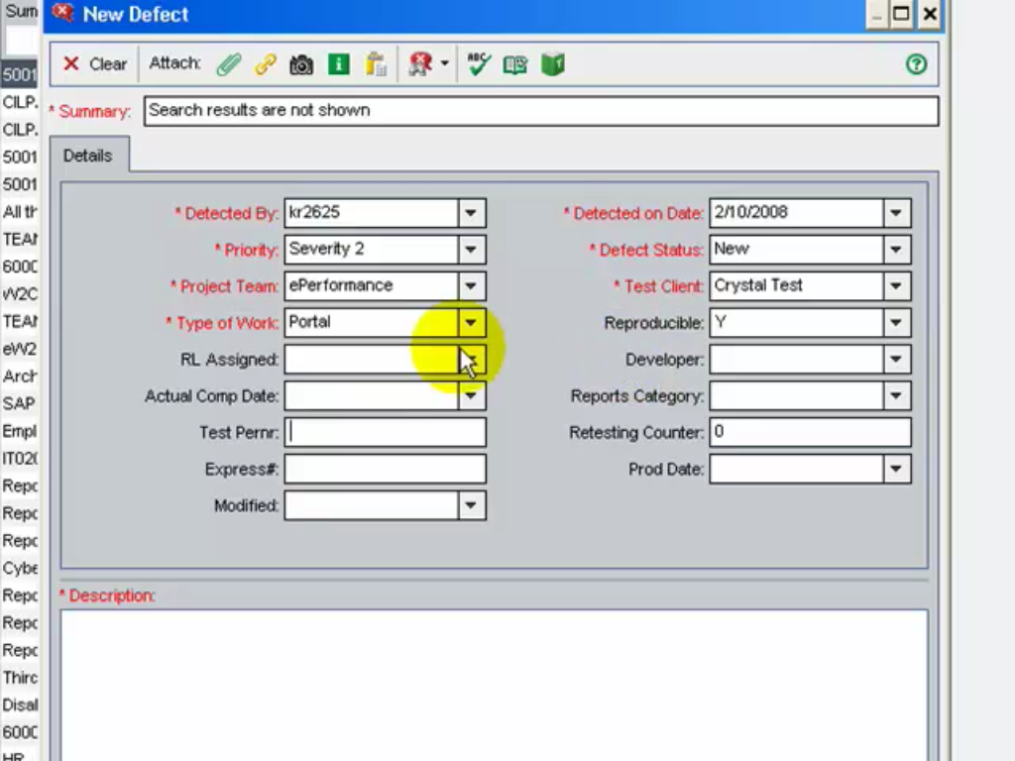

Link Defects in Quality Center

* You can link a test in your test plan ,to a specific defect in the Defects Grid ,inQualityCenter
* Linkage is helpful when new test is created for a existing defect , or there is a change in requirements which is linked to a defect.
* Linkage can be done  directly or indirectly.
* When you directly Link a defect to a Run, Quality Center indirectly links the defect to the Test instance, Test Set , Test and  Requirements

However the linkage is unidirectional i.e. when you link a Defect to run, it is not indirectly linked to run step

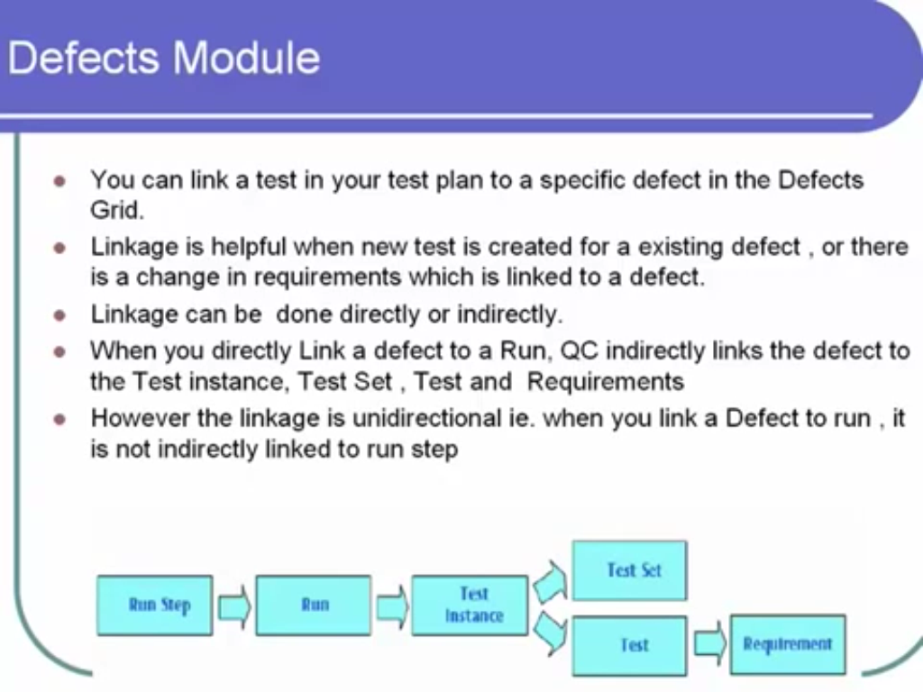

How to use Favorites in Quality Center

* You can create  favorite view in Quality Center window with your own custom settings. Example, in defects grid, you may want create a favorite view to [show[](http://www.guru99.com/quality-center-tutorial-11.html)](http://www.guru99.com/quality-center-tutorial-11.html) only defects detected by you or assigned to you.
* A favorite View can be public or private.
* Private favorite is visible only to you.

Public favorite is visible to all Quality Center users.

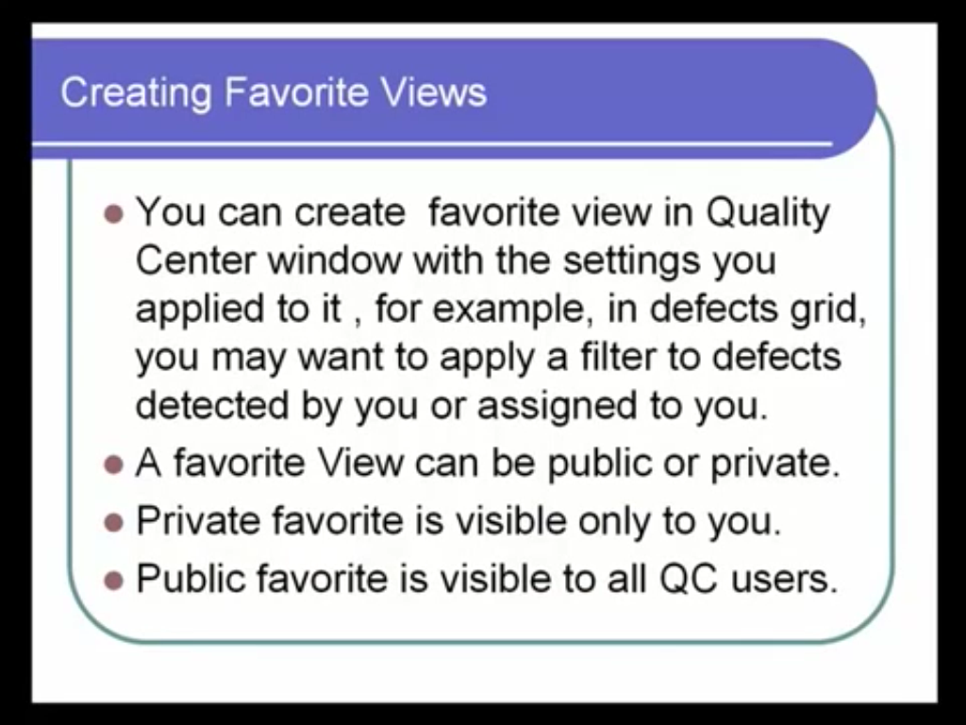

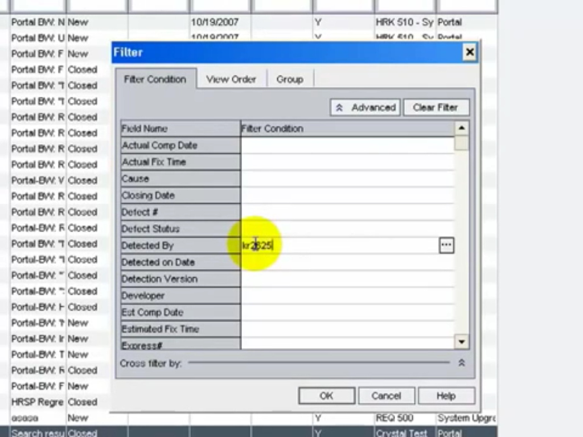

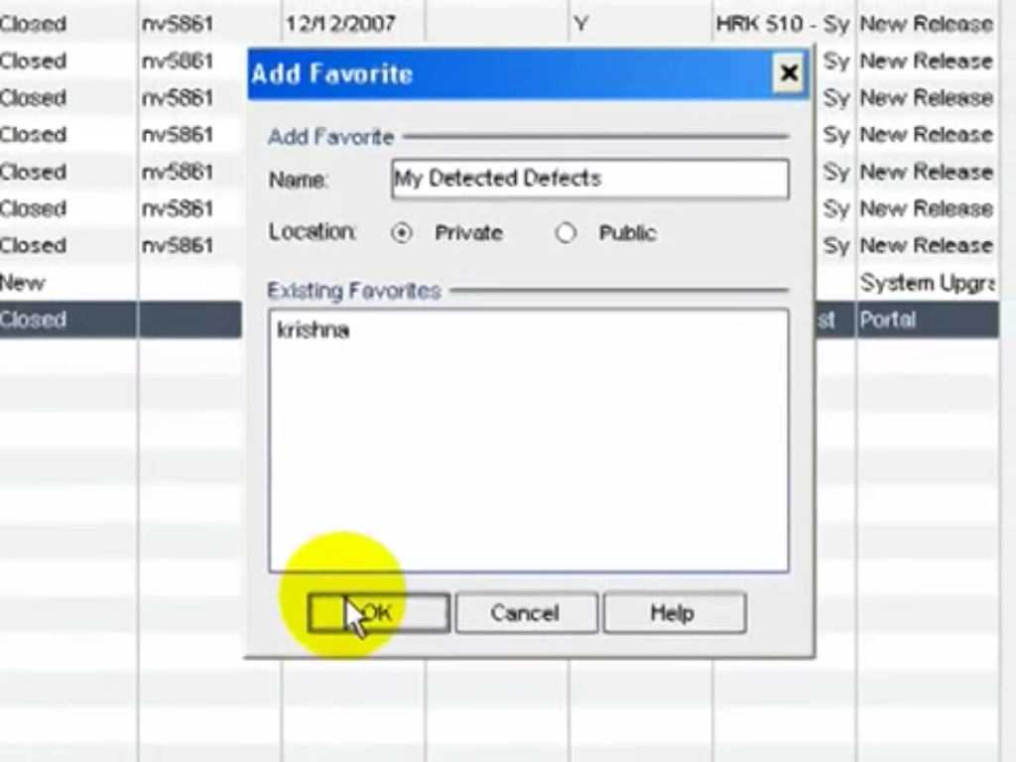

Traceability in Quality Center

You can instruct Quality Center to create alerts automatically and send email to notify those responsible when changes occur in your project that may impact the [testing](http://www.guru99.com/software-testing.html) process.

Traceability can be achieved in two ways 1) Automatic Alerts & 2)Follow Up alerts

|  |  |
| --- | --- |
|  | Automatic Alerts   * Automatic Alerts generation depend on the configuration set by your Quality Center administrator * Examples of Automatic Traceability alerts are when a requirement changes, the designers of associated test are notified, when the status of a defect changes to "Fixed", the responsible tester of the test instance is notified.   Follow Up Alerts   * You can use follow up flags to remind yourself to follow up on something. * You can set follow up flags for  a test in the test plan tree or Test Grid, a test instance in the Execution Grid &  a defect in the Defects Grid * You can view or modify existing alerts. |

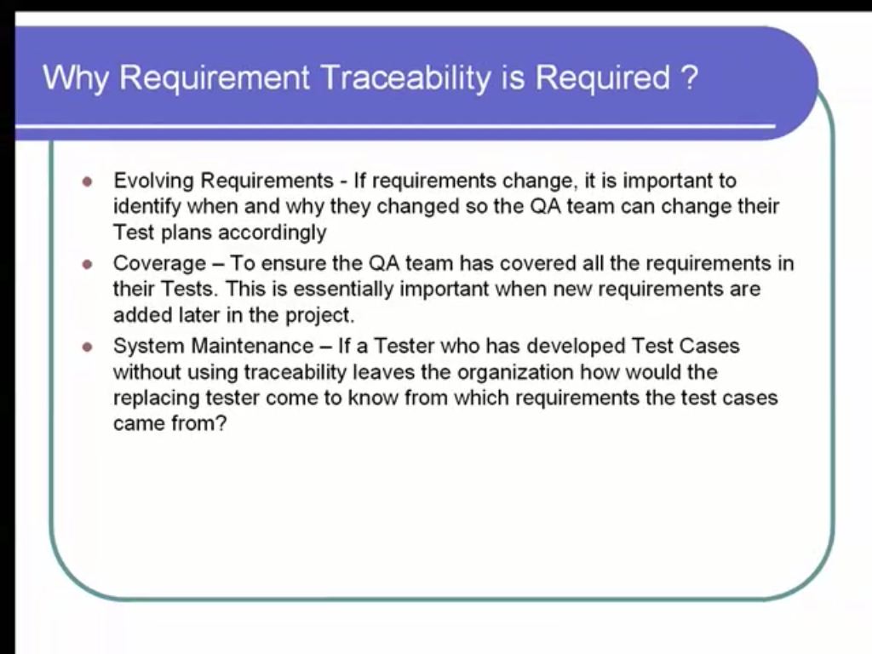

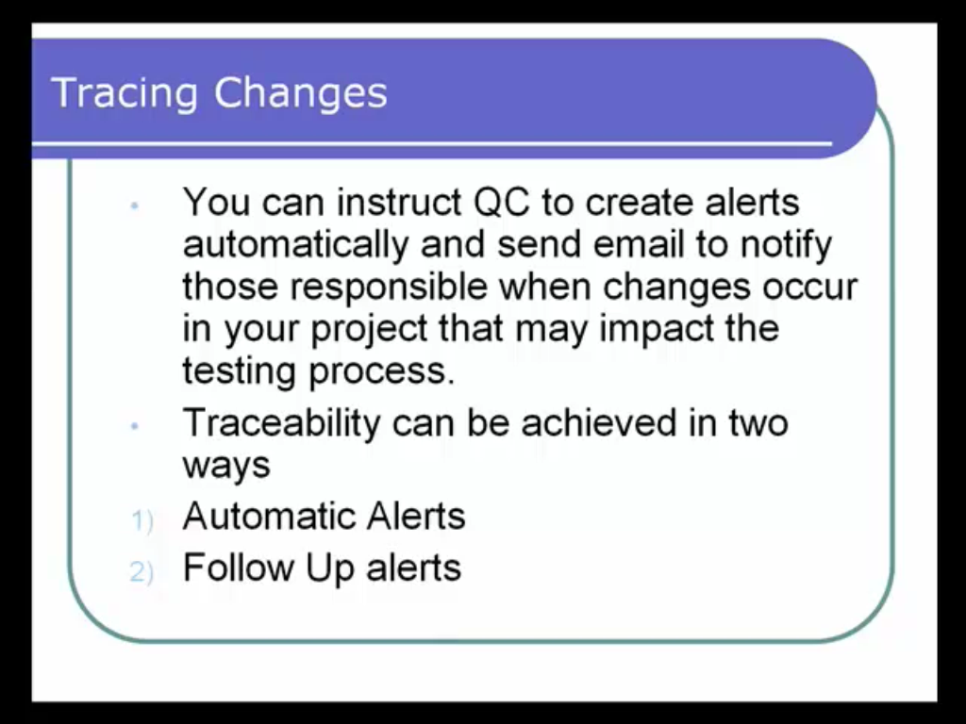

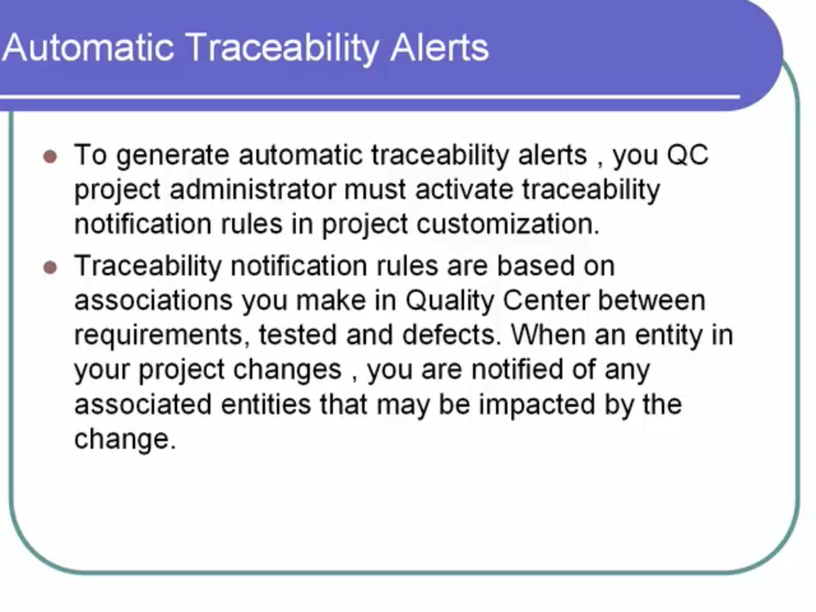

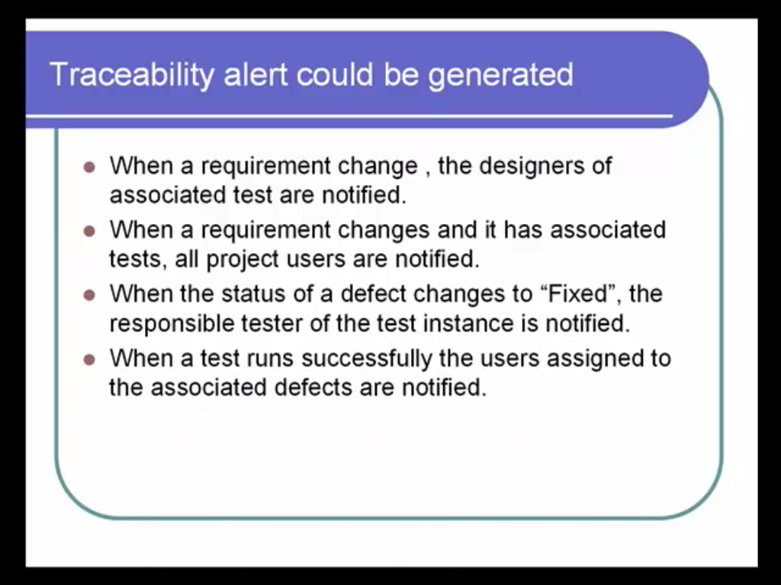

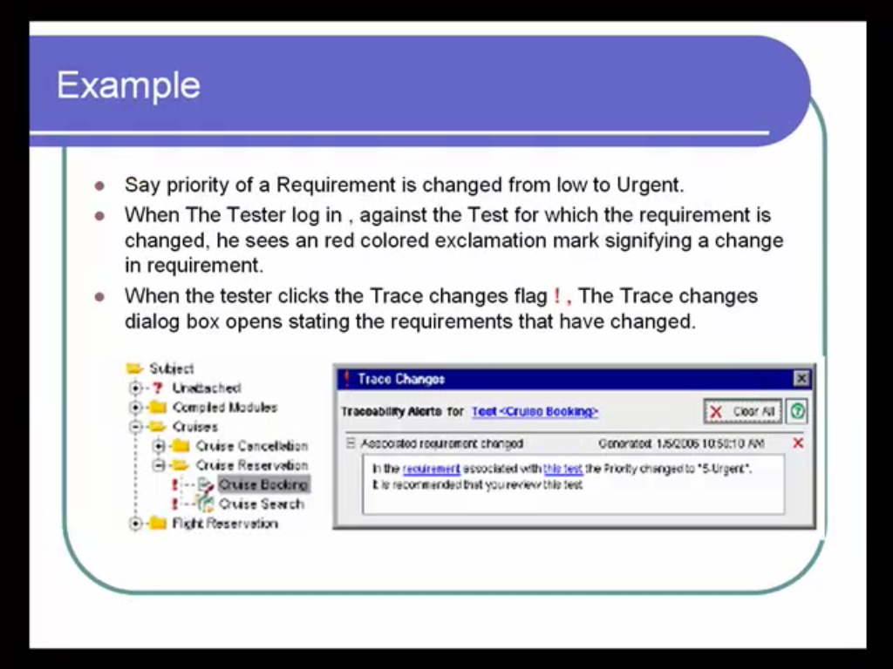

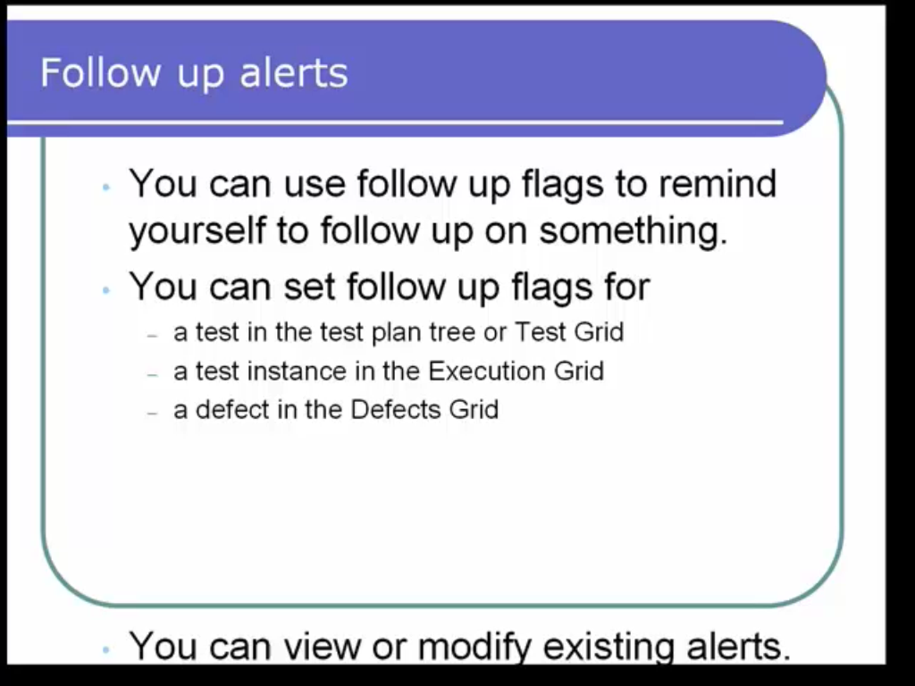

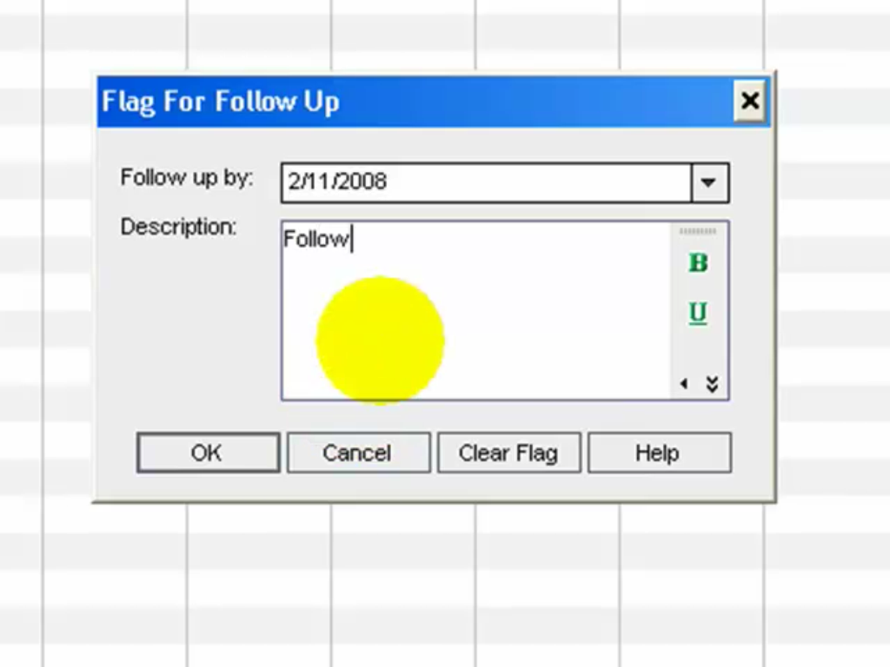

Why graphs and reports are important in quality center

* Quality Centerprovides for Reports and Graphs to help in analysis , test monitoring and take quick test control decisions.
* Standard Reports and Graphs like Summary, Progress and  Trend are available in all modules

Quality Center allows you to customize reports as per requirements.

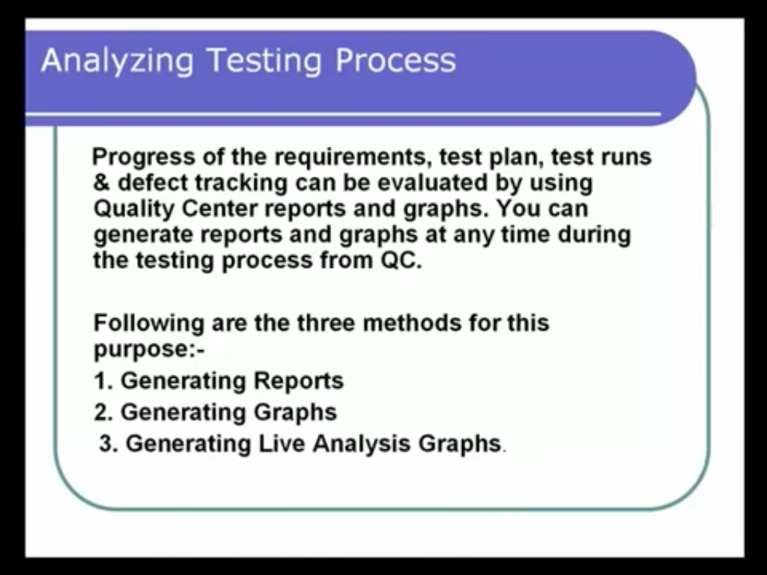

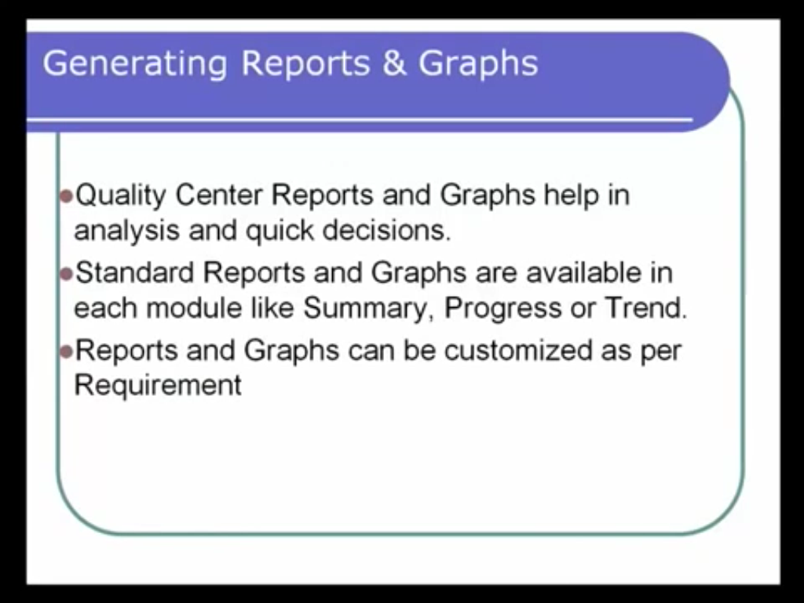

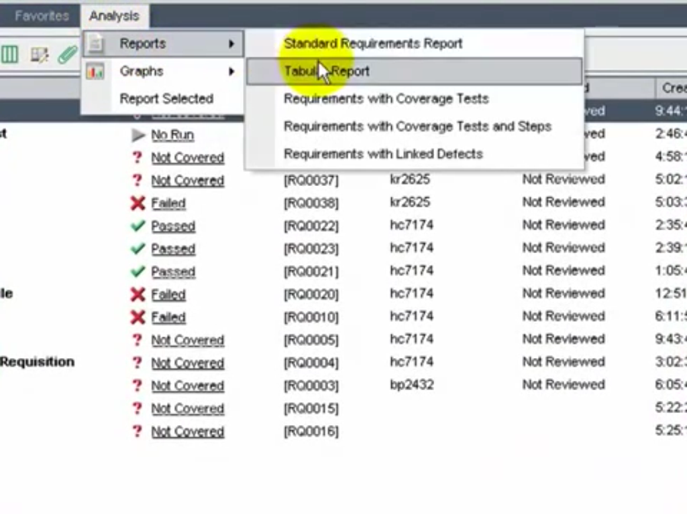

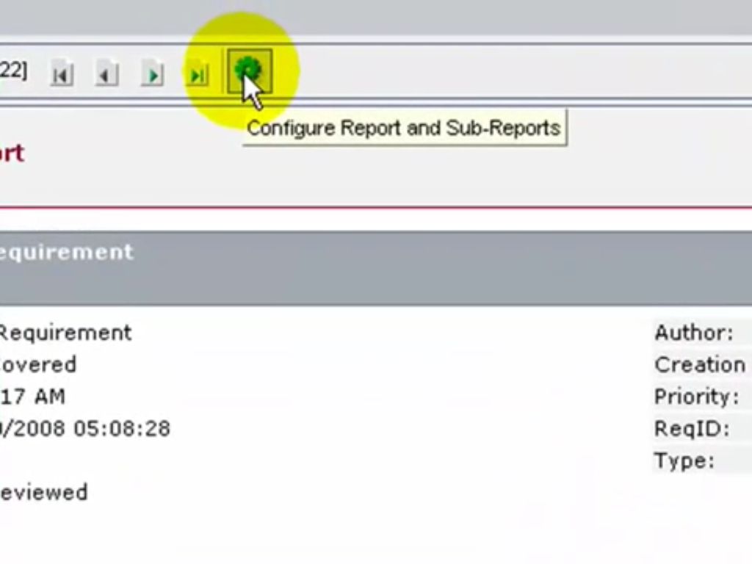

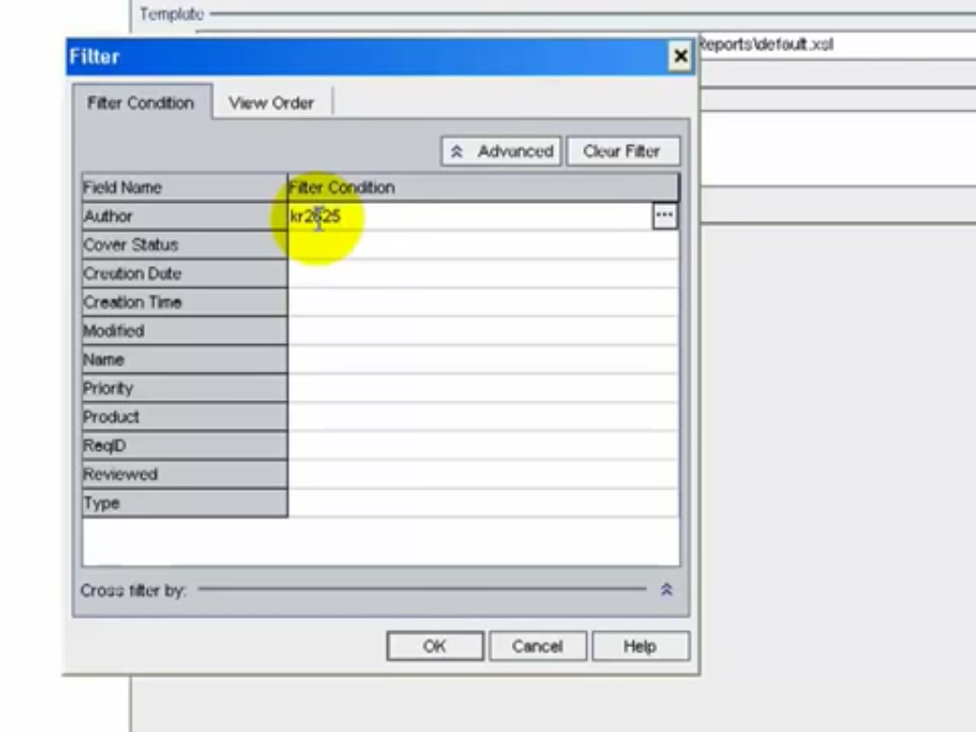

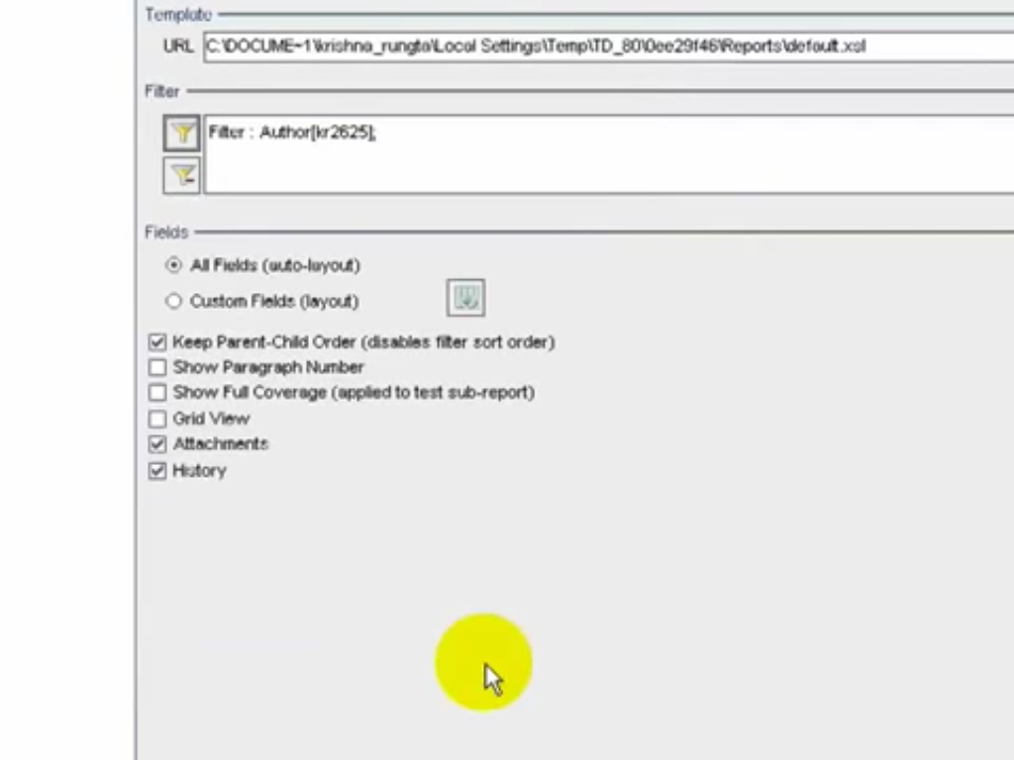

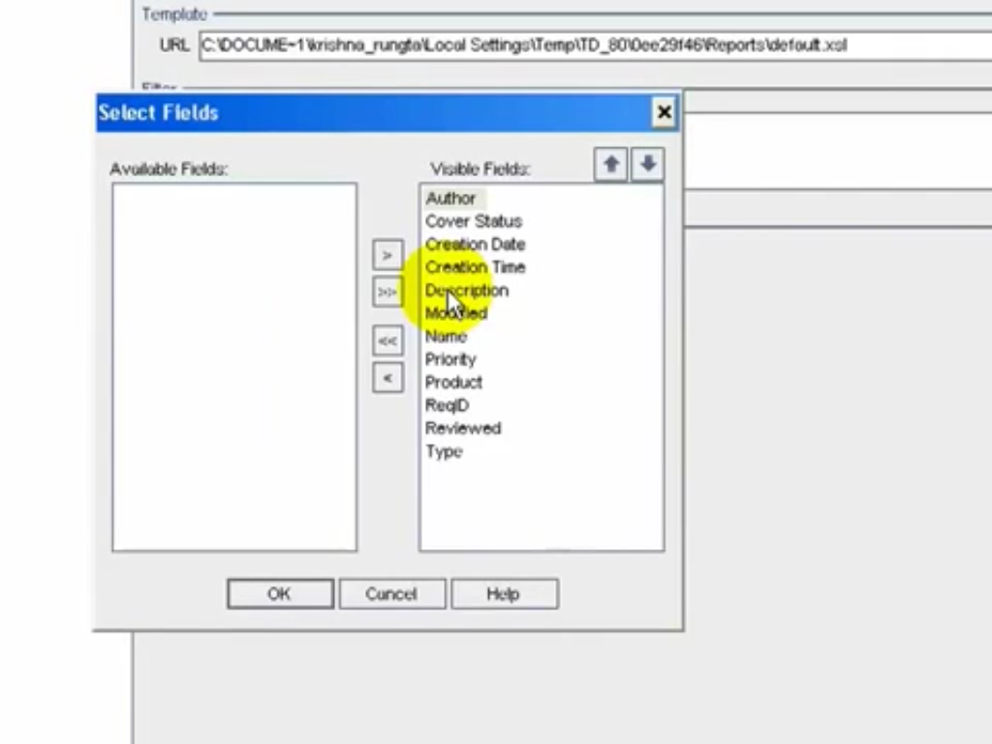

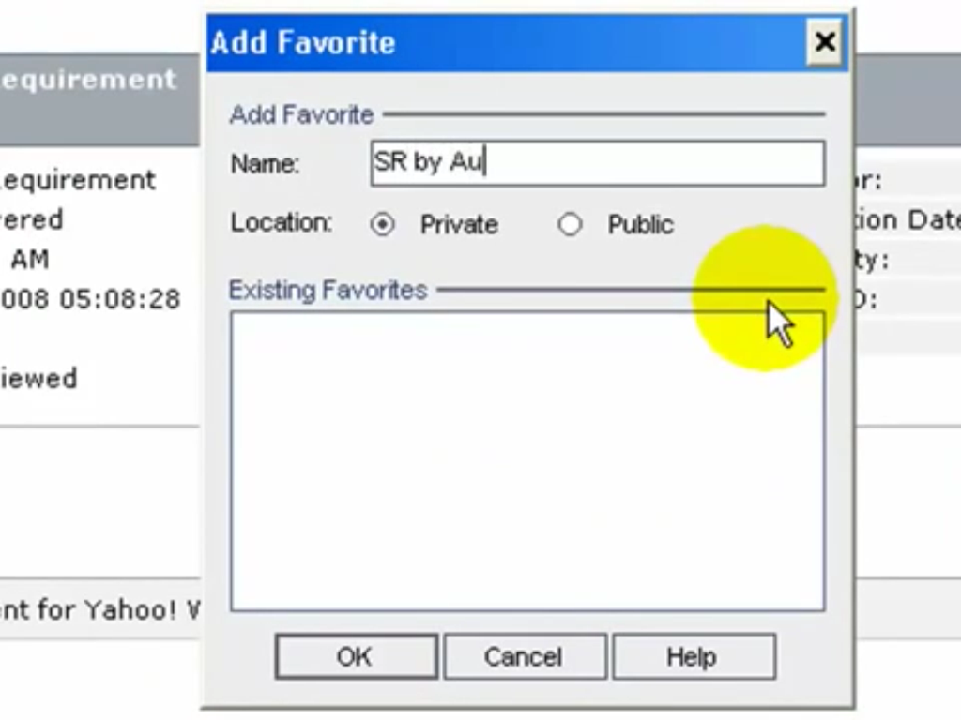

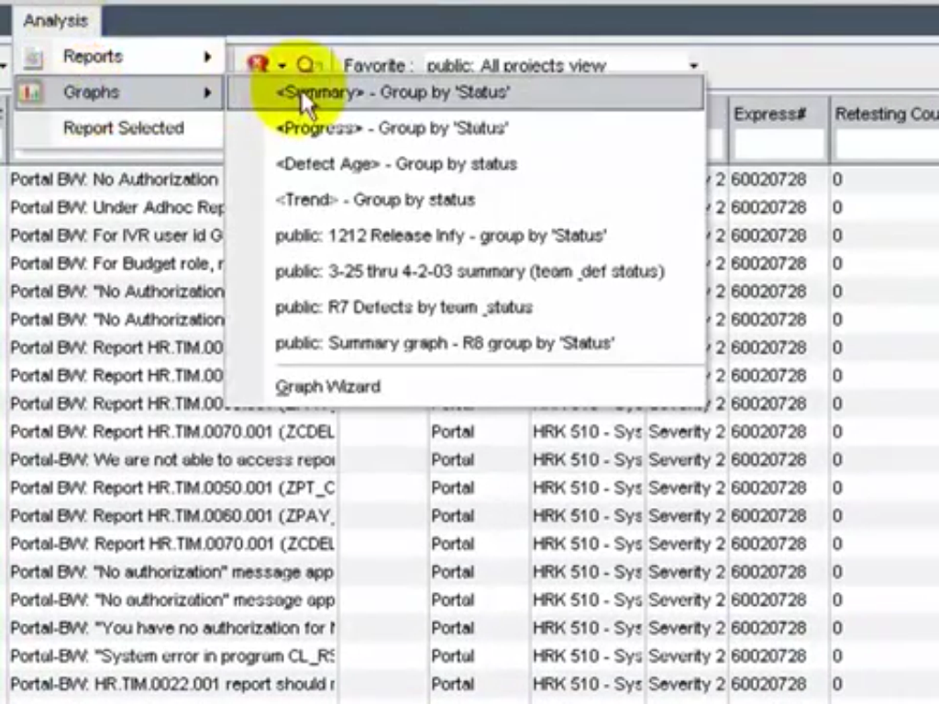

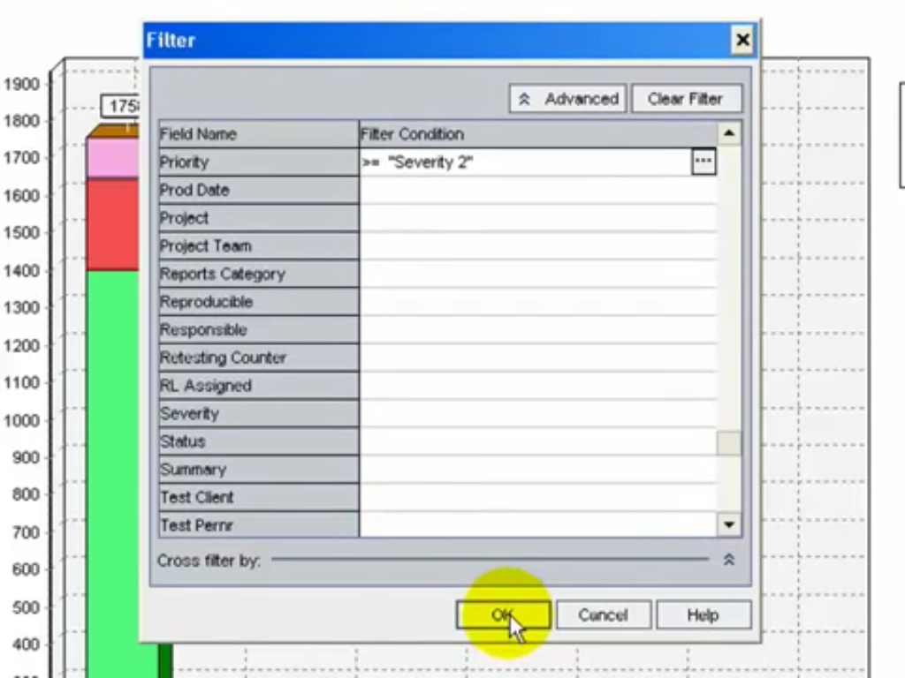

How to use Live Analysis Graphs in Quality Center

* Quality Centerprovides for  Live analysis to facilitate  dynamic and quick [visual[](http://www.guru99.com/quality-center-tutorials-14.html)](http://www.guru99.com/quality-center-tutorials-14.html) overview of all tests in the test subject folder or test sets in test set folder.
* Live Analysis differs from other graphs, in that ,you do not have to recreate the graph to view data that has changed. Hence the name "Live"

Also the layout and settings of the graphs are preserved when you select another folder in the same module in Quality Center.

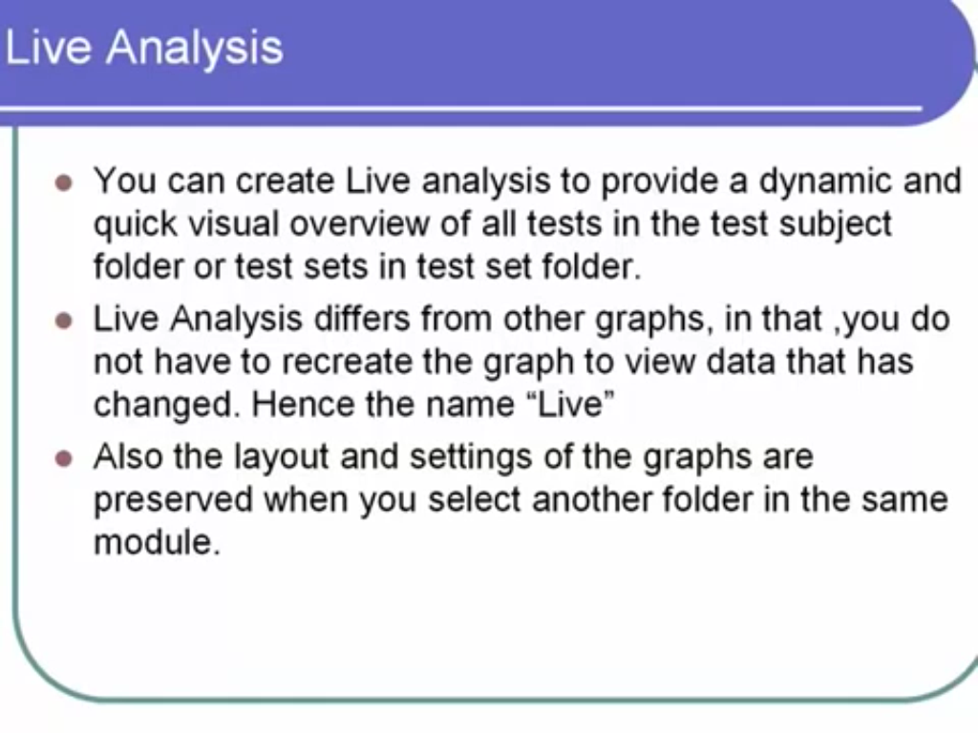

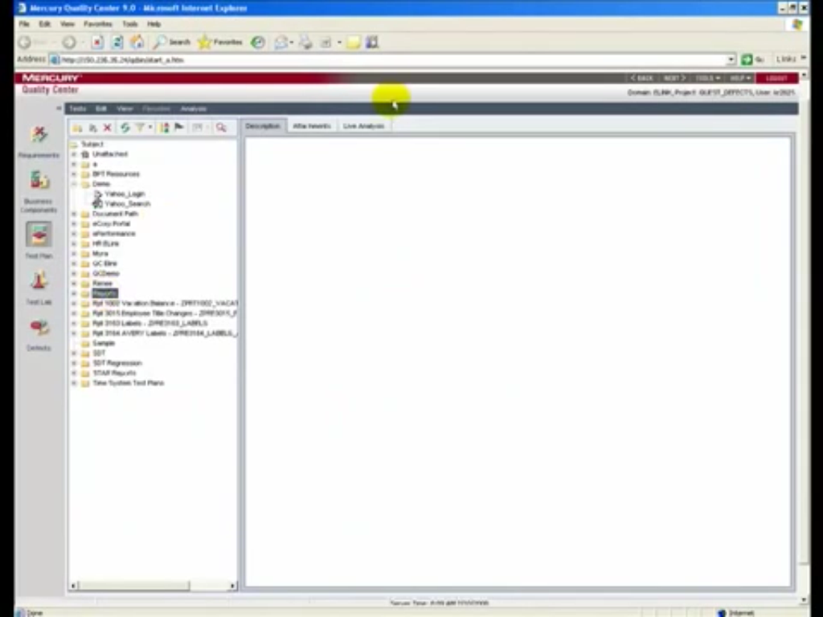

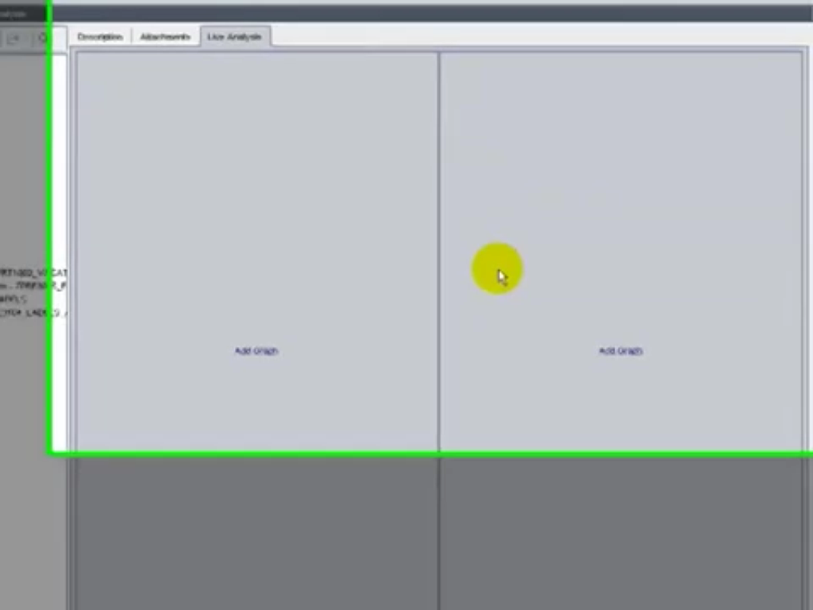

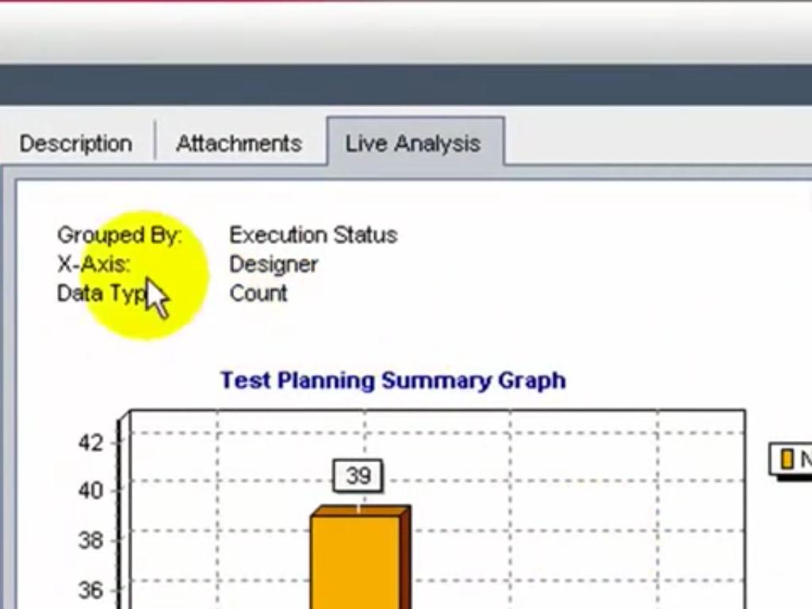

<http://www.guru99.com/quality-center-tutorials-14.html>